Dear Third Grade Parents,

It’s animal time! As a culmination of our science unit on the roles of living things, your child will be responsible for choosing an animal and reporting on this animal. Each student can choose how he/she would like to present this animal. I encourage students to check out books from our library to research this animal. The kids will be looking for animal books this Thursday. If your child chooses to research online, I have listed a credible website below. This animal project should be creative, exciting, informative, and display your child’s best work. Each student must include an animal report form with this assignment. Please help your child with this assignment. This assignment will be due back to school by: FRIDAY, DECEMBER 19, 2014. It can be turned any time before this date too. Please do not hesitate to email me if you have any questions.

Sincerely,

Liz Schrein

Website for animal research: <http://www.worldbookonline.com>

*See the attached forms*

**Ideas for Your Animal Project: (Circle the one you’d like to do and give this form to Mrs. Schrein as soon as possible.)**

Tri-Fold Poster board

Book Report

Make a Model of your Animal (Clay, Paper, etc.)

Brochure

Write a Song/Rap/Poem/Speech

Make a Movie/Video

PowerPoint Presentation

Dress Up like your Animal and Make a Speech

Make an Art Project

Other: ______________________________________________________________

(Must be approved by Mrs. Schrein)

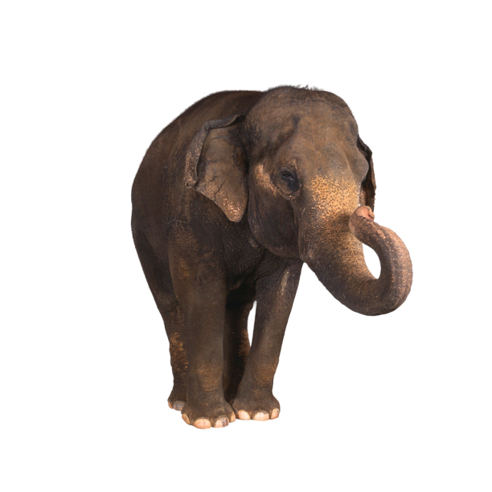C:\Users\tgoliday\AppData\Local\Microsoft\Windows\Temporary Internet Files\Content.IE5\CONT1HUS\MC900324476[1].wmfC:\Users\tgoliday\AppData\Local\Microsoft\Windows\Temporary Internet Files\Content.IE5\QGHLW3Y0\MC900052966[1].wmf

Name:__________________Date:____Number:____

Animal Report

Graphic Organizer (To help organize your report)

|  |  |
| --- | --- |
| What is the name of your animal? | Animal classification? (Mammal, bird, reptile, amphibian, or fish) |
| Body Covering? | Behavior and Adaptation? (How does your animal protect itself) |
| What does your animal eat? | What habitat does your animal live in? |
| Name an interesting fact about your animal. | Is your animal a vertebrate or an invertebrate? |

Name:__________________Date:____Number:____

Use the information from the Graphic Organizer to write a paragraph about your animal. Turn this in with your Animal Report Project.

|  |
| --- |
|  |
|  |
|  |
|  |
|  |
|  |
|  |
|  |
|  |
|  |
|  |
|  |
|  |

Animal Report Rubric:

Name: _____________________________________________________

You will be graded on the following:

* Creativity and Craft (Decorating, Uniqueness, WoW Factor!)—25 points
* Accurate Information (The Information You Present is Correct, Relevant, and Accurate) –25 points
* Timeliness (Turned in on Time) –25 points
* Neatness (Examples might include: Handwriting, Illustrations, Images, Coloring, Typing)—25 points
* Oral Presentation (Speaking Clearly and Loudly, Easy to Understand, Enthusiasm)—25 points

You are not required to type your presentation, but you may! You have the freedom to create this project any way you’d like. Please remember that it is important to give accurate information and to make this project look amazing!

I am so excited to see what you will come up with! Work hard! Let me know if you will need anything to create this project.